 | 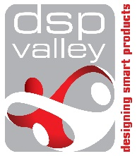 | 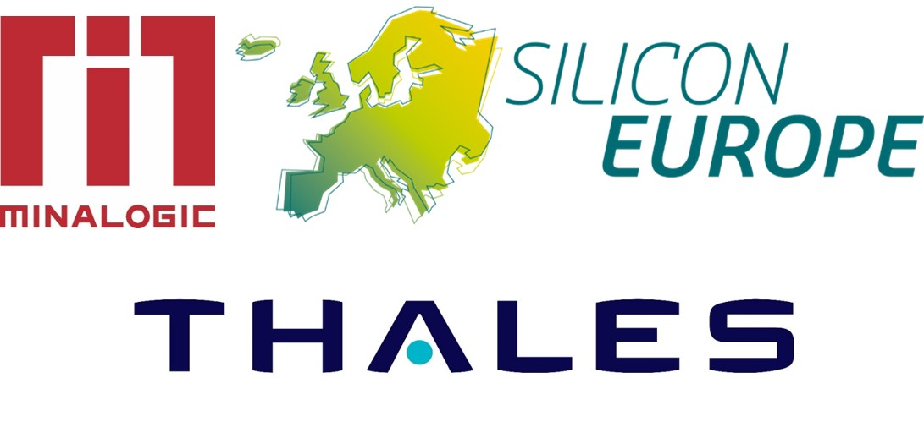

Open Innovation day with Boston Scientific

Enabling Innovation in Smart Health Solutions together with Boston Scientific

Tuesday December 4th, 2018 from 9:00 am to 5:30 pm
Health House, Leuven (Belgium)

REGISTRATION AND APPLICATION FORM

> Company

Company Name:
Website address:

> Contact Person

Name:
First Name
E-mail:
Mobile Phone:

> Membership
Are you member of a Silicon Europe Alliance cluster? Yes ☐ No ☐
If yes, which one?

BCS (NL) ☐ | Distretto G&HT (IT) ☐ | DSP Valley (BE) ☐ | GAIA (ES) ☐
High Tech NL (NL) ☐ | MESAP (IT) ☐ | MIDAS (EI) ☐ | Minalogic (FR) ☐
SCS (FR) ☐ | Silicon Alps (AT) ☐ | Silicon Saxony (DE) ☐ | TechWorks (UK) ☐

Are you member of another cluster? ………………………………………………………………………………..

> Description of your activities

> Areas of interest : please check the appropriate box(es)
1 | 2 | 3 | 4
Fiber Optics | Miniaturisation of Electronics and Electronics Packaging | Fluidics | Ultrasound Technology

5 | 6 | 7 | 8
IoT in Smart Packaging & Supply Chain Management | Systematic Firmware Development for Medical Devices | Energy Technologies | Any Other Technologies

> Description of your unique expertise and know-how according to your choice(s)

> Customers

> Key words

> What kind of cooperation do you expect from Boston Scientific

Joint (funded) innovation project to develop technology ☐
Boston Scientific to buy technology from supplier ☐
Boston Scientific to invest in the supplier company ☐
Other (please specify): ………………………………………………………………………………

> Have you ever interacted with Boston Scientific before?

Yes ☐ No ☐

If yes, please give a short description and your contact person(s) at Boston Scientific

> Comments

Please fill out this Application Form and submit it to your cluster or to DSP Valley
by September 28th, 2018

